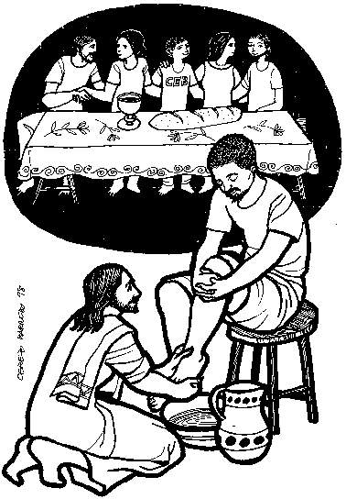

HOLY WEEK & EASTER 2025

(Monday 14th April to Easter Sunday 20th April)

Holy Week this year – Maundy Thursday, Good Friday and Holy Saturday are joint celebrations at Coxhoe for all three churches. Please remember these Liturgies take precedence over other devotional activities. I encourage you to participate as fully as you are able.

TUESDAY: Mass at Trimdon – 10.00am followed by Stations of the Cross

WEDNESDAY: No Mass at Coxhoe because of Chrism Mass at the Cathedral.

MAUNDY THURSDAY: Evening Mass of the Lord’s Supper & Watch at the Altar of Repose
NB. Coxhoe only - 7.00pm - Watching until 9.00pm

GOOD FRIDAY: Liturgy of the Passion, Veneration of the Cross and Holy Communion
NB. Coxhoe only – 3.00pm – Good Friday Liturgy of the Passion

Trimdon – 10.00am at St. Mary Magdalene’s Procession of Witness

Sedgefield – 10.00am at St Edmunds - Procession of Witness
(Churches together)

HOLY SATURDAY: Liturgy of Light, Vigil and 1st Mass of Easter
Coxhoe: 6.00pm

EASTER DAY: Sunday Masses as follows:
9.15 at Trimdon & 10.45am at Sedgefield
Confessions at usual times or by appointment
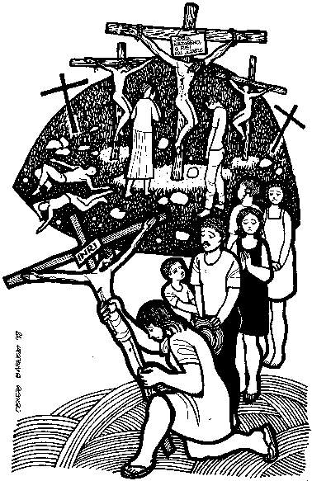 Note. Please check bulletins for confirmed times.

